Online Shopping Management System - MSIKI

Software Architecture Document

Version 1.0

Revision History
Date | Version | Description | Author
29/11/2024 | 1.0 | Final Project | All members

Table of Contents

1.Introduction 4
1.1 Purpose 4
1.2 Scope 4
1.3 Definitions, Acronyms, and Abbreviations 4
1.4 References 4
1.5 Overview 4
2. Architectural Representation 4
3. Architectural Goals and Constraints 4
4. Use-Case View 4
5. Logical View 5
5.1 Overview 5
5.2 Architecturally Significant Design Packages 5
5.3 Use-Case Realizations 5
6. Process View 5
7. Deployment View 5
8. Implementation View 5
8.1 Overview 5
8.2 Layers 5
9. Data View (optional) 6
10. Size and Performance 6
11. Quality 6

Software Architecture Document

Introduction

Purpose
This document provides a comprehensive architectural overview of the system, using a number of different architectural views to depict different aspects of the system. It is intended to capture and convey the significant architectural decisions which have been made on the system.

Scope
This document pertains to the Online Shopping System, MSIKI, which is set to be created by Team 38

Definitions, Acronyms, and Abbreviations
User: An individual who interacts with the system, either as a customer or an employee.
Admin: A person responsible for managing and organizing the system.
Seller: A user who utilizes the system to sell products.
Customer: A user who utilizes the system to purchase products.

References
None

Overview
The following section delves into the detailed architectural design of the Online Shopping System, Tiki. Initially, the core software architecture of the system will be outlined. This will be followed by an in-depth discussion of the objectives and constraints influencing the quality of the final product, encompassing aspects such as security, scalability, and reusability. In preceding sections, the system's key views are presented to illustrate various perspectives. Finally, criteria related to the system's size, performance, and overall quality will be proposed.

Architectural Representation
This document outlines the architecture through a series of essential perspectives: the Use-Case View, Logical View, Deployment View, and Data View. These views are presented using Diagrams.net models and adhere to the Unified Modeling Language (UML) standards.
Use-Case View
-Audience: All stakeholders of the system, including end-users.
- Focus: Details the scenarios and use cases that encapsulate the system's core functionality.
- Related Artifacts: Use-Case Model, Analysis Model, Use-Case Realization documents.
Logical View
- Audience: Designers and developers.
- Focus: Addresses functional requirements by describing the object model of the system design.
- Related Artifacts: Design Model.
Deployment View
- Audience: Deployment managers and system administrators.
- Focus: Explores system topology, mapping software components to hardware and showcasing distributed aspects of the system.
-Related Artifacts: Deployment Model.
Data View
- Audience: Data specialists and database administrators.
- Focus: Highlights architecturally significant elements within the data model, particularly persistent data structures.
- Related Artifacts: Data Model.

Architectural Goals and Constraints
The architecture of the Online Shopping System MSIKI is influenced by several critical requirements and constraints, as outlined below:
- The system must be designed to fully comply with all specifications outlined in the requirements definition.
- The design should be robust and adaptable, ensuring ease of modification in response to evolving functional requirements.
- To ensure efficient development, the design must support the reuse of business logic across different applications.
- The system’s design should facilitate seamless cooperation between various development teams by clearly defining the responsibilities of different components.
- The system will operate on a dedicated platform with direct access to a database, ensuring reliable performance.
- The MSIKI website, which serves as the primary content display platform, must include an interface capable of managing high traffic volumes efficiently.

Use-Case View

Use-Case Overview

The Use Case View is an important input to the selection of the set of scenarios and/or use cases that are the focus of an iteration. It describes the set of scenarios and/or use cases that represent some significant, central functionality. It also describes the set of scenarios and/or use cases that have a substantial architectural coverage (that exercise many architectural elements) or that stress or illustrate a specific, delicate point of the architecture.
The significant use cases in this system are listed below:
- Manage Account (Authentication, Manage Profile )
- View System Interface
- Manage Users
- Manage System Interface (Manage System Category, Manage Ads )
- Manage Product
- Manage Collection
- Manage Marketing (Manage Promotion Tool, Manage Order Value Boosting Tool)
- Search Product
- Manage Cart
- Make Payment
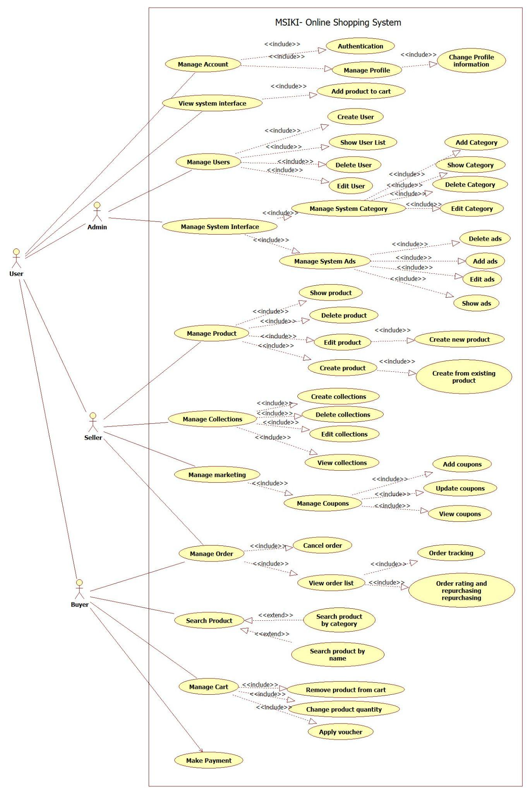

Use-Case Realization
Manage Profile
Use case name | Manage Profile
Scenario | User log in and go to profile page, then edit there profile.
Triggering event | Click on register/login button, fill in information and submits.
Brief description | This document will describe the way for users to manage their profiles. It contains changing passwords,and changing profile information.
Actors | User
Related use cases | None.
Preconditions | User logs in successfully
Post conditions | All information will be saved and updated
Flow of events | Go to manage profile page  Change Password and profile information  Click update profile
Exception conditions | User enters wrong password and field format.

Manage Users
Use case name | Manage Users
Scenario | Admin redirects to User list page to create, delete, and update Users.
Triggering event | Click on Manage User button.
Brief description | This use-case describes the admin managing the users of the Shopping system with four main functions: Create User, Show User, Delete User, Edit User.
Actors | Admin
Related use cases | None.
Preconditions | The User must log in as admin role,  An User must exist to delete and edit.
Post conditions | If the admin deletes, creates, edits user the system return message to let admin know these action success or failed.  The table in User list page must change as change in the database.
Flow of events | Enter manage User page.  Create new User.  Edit an existing User.  Delete an existing User.
Exception conditions | None.

Manage Collections
Use case name | Manage Collections
Scenario | The admin navigates to the Collections list page to manage the creation, deletion, and updating of Collections.
Triggering event | Click on the Manage Collection button.
Brief description | This document outlines the process for sellers to handle their collections, including creating new collections, editing existing ones, deleting collections, and viewing them.
Actors | Seller
Related use cases | Manage Product.
Preconditions | After successfully logging in, sellers access the “Store Design” page and select “Collection.” Existing collections are available for updates or deletions.
Post conditions | New collections are created, and those that require updates or deletions have been successfully modified or removed.
Flow of events | Access the manage Collection page  Create a new Collection.  Edit an existing Collection.  Delete an existing Collection.
Exception conditions | If sellers do not provide all the necessary information for the coupon, clicking the “Save” button will not redirect them to the Collection page. Instead, they will remain on the “Create New” page and be prompted to complete the missing fields with alerts in each corresponding box.

Manage Coupons
Use case name | Manage Coupons
Scenario | The admin navigates to the Coupons list page to manage the creation, deletion, and updating of Coupons.
Triggering event | Click on the Manage Coupons button.
Brief description | This document serves as a guide for sellers to manage their brand's coupons on MSIKI. It specifically outlines the process for creating new coupons, as well as viewing and updating existing ones.
Actors | Seller
Related use cases | Manage Products
Preconditions | Sellers must log in to their accounts, navigate to the marketing center page, and select promotion tools. There must be existing records of coupons available for updates and status changes.
Post conditions | New coupons can be created easily through the interface. Coupons that require updates can be modified as needed, and the status of other coupons can be changed to either "active" (visible to customers) or "inactive" (invisible to customers).
Flow of events | Access the Manage Coupons Page.  Create a new Coupon.  Edit an existing Coupon.  Delete an existing Coupon.
Exception conditions | If sellers do not provide all the required information for the coupon, clicking the "Create" button will not redirect them to the "Checking" window. Instead, the system will prompt them to complete the missing fields by displaying alerts in each of those respective boxes.
Search Product
Use case name | Search Product
Scenario | Buyer enters the product name in the search box and clicks on the search button.
Triggering event | The buyer enters information on the search box.
Brief description | There will always be a search engine area with a search box and a few categories at the top of the web-page that the user is viewing, no matter where or when the user is viewing it. Users can either key in the name of the product they're looking for or search by product category.
Actors | Buyer.
Related use cases | Search Product by Name.  Search Product by Category.
Preconditions | The user must be logged-in as a buyer.
Post conditions | Return Product List.
Flow of events | User enters a product name or selects a category.  System processes the input and queries the database.  If matches are found, the product list is displayed.  If no matches are found, a "no results" message is shown.
Exception conditions | Search query is empty: The system prompts the user to enter a search term.

Manage Product
Use Case Name | Manage Product
Scenario | The seller accesses the product management page to create, update, or delete products.
Triggering Event | Seller clicks on the "Manage Product" button in their dashboard.
Brief Description | This use case allows sellers to manage their product inventory by adding, editing, or removing product listings.
Actors | Seller
Related Use Cases | Manage Collections
Preconditions | The seller must log in successfully and have access to the product management interface.
Post Conditions | Product data is updated in the system database, and changes are reflected on the customer-facing platform.
Flow of Events | Seller accesses the "Manage Product" page.  Seller selects an action: Create, Edit, or Delete a product.  For Create/Edit: Seller fills out or updates product details (e.g., name, price, description, stock).  For Delete: Seller confirms the deletion of a product.  System processes the request and updates the database.
Exception Conditions | Missing mandatory fields: System alerts seller to complete required fields before submission.  Invalid input (e.g., unsupported characters): System notifies seller of the issue.

Manage order

Use case name | Manage Orders
Scenario | Admin redirect to Orders list page to create, delete, and update Collections.
Triggering event | Click on Manage Order button.
Brief description | This document will describe the way for customers to manage their orders. It contains viewing order list, view tracking of each order, cancel order and write feedbacks or repurchase for successful delivery.
Actors | Customer
Related use cases | Manage Coupons.  Manage Cart.
Preconditions | Customers log in successfully  Customers have at least 1 order in order list  Check status exactly before allowing customers to cancel or write feedback and repurchase.
Post conditions | The orders that need to be cancelled have been cancelled successfully  Feedback for successful delivery saved
Flow of events | Enter manage Orders page.  Create new Order.  Edit an existing Order.  Delete an existing Order.
Exception conditions | None
Manage cart

Use case name | Manage Cart
Scenario | Admin redirect to Make payment page to choose and enter payment form.
Triggering event | Click on Purchase button.
Brief description | There will always be a search engine area with a search box and a few categories at the top of the web-page that the user is viewing, no matter where or when the user is viewing it. Users can either key in the name of the product they're looking for or search by product category.
Actors | Customer.
Related use cases | Add Coupons.  Make Order.
Preconditions | The user must login as an customer role.  The user must choose at least one product to buy.
Post conditions | Send back payment confirm message  Return receipt
Flow of events | Select products  Delete Products  Change Product Quantity  Change Address  Apply Voucher
Exception conditions | None

Logical View

Overview
the Online Shopping Management System - MSIKI is designed using a structured approach based on the Model-View-Controller (MVC) design pattern, which divides the system into three interconnected packages: Model, View, and Controller. This architecture ensures modularity, scalability, and efficient handling of core functionalities, user interactions, and data management:
- The Model handles the product catalog, user accounts, order management, and inventory updates. It also manages customer accounts, including login credentials, addresses, and order histories, while processing orders and tracking their statuses.
- The View package focuses on presenting data to users through a dynamic and interactive user interface. Key components include the home page, product listing pages, shopping cart, and summary pages.
- The Controller package processes user actions, updates the Model's state, and ensures that relevant data is passed to the View for display. It handles search and filter requests, allowing users to refine product searches. It also manages checkout by coordinating payment, address verification, and order placement. Additionally, the Controller validates user login credentials, maintains session security, and synchronizes updates to reflect changes in the shopping cart and inventory.
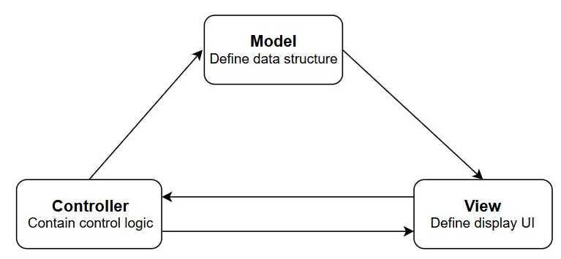

Architecturally Significant Design Packages
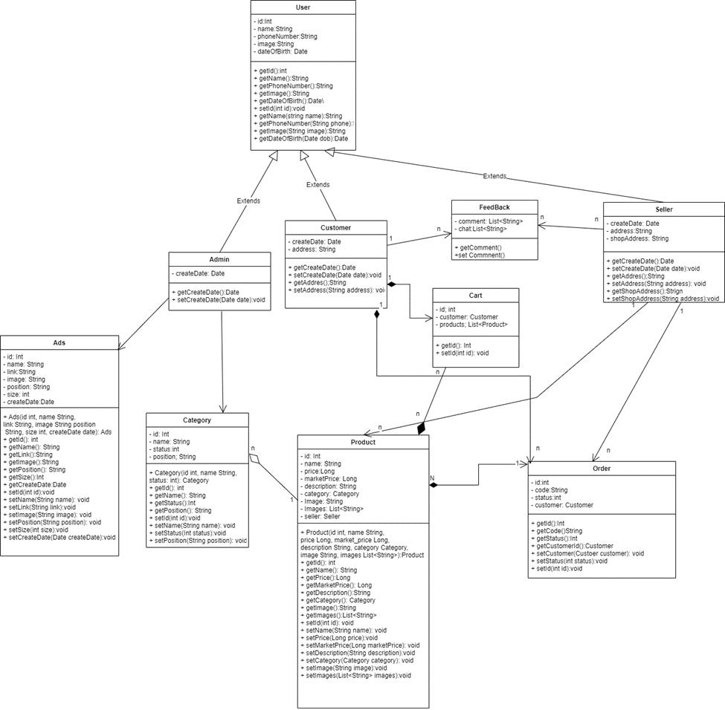

Process View
* User Change Profile Information
When the user clicks on account management the page will redirect to the manage profile page. The user will enter/change the information that needs to be updated. Then the system will validate the changed information. If there is no error the system will update the user information in the database and return a success message, else the system will return an invalid information error.
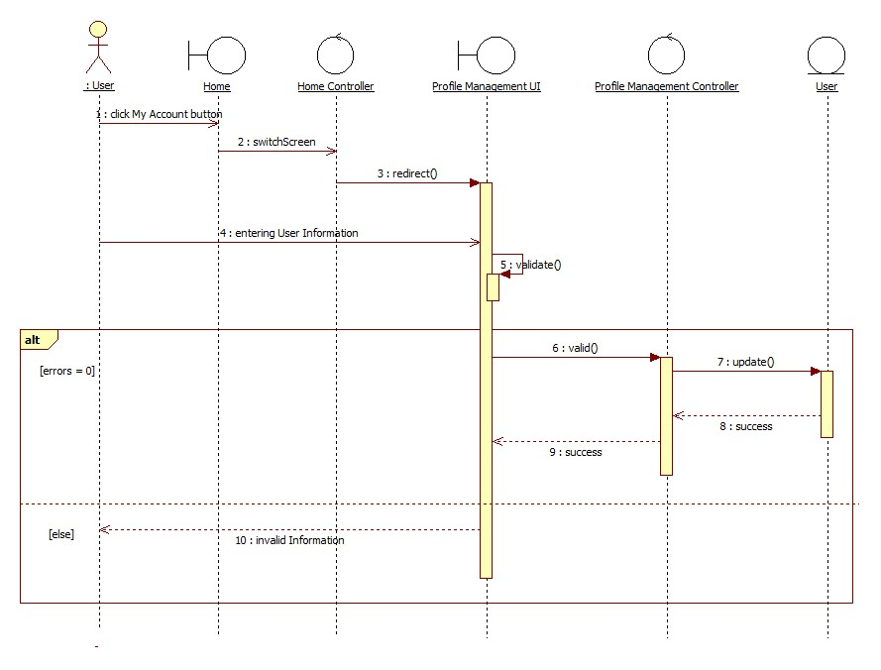
* Admin Manage User
The page will redirect to the user information view page when the admin clicks the create user or edit user buttons. They will enter the user's information here, which will be verified by the system. If the information is valid, the system will add or update the user's information in the database, and a success message will be displayed. If the information is incorrect the system will return an error message. When the admin clicks on the delete button, the user’s information that the admin chooses to delete will be erased from the database. If there are no errors, the system will return a successful message; otherwise, it will return an unsuccessful message.
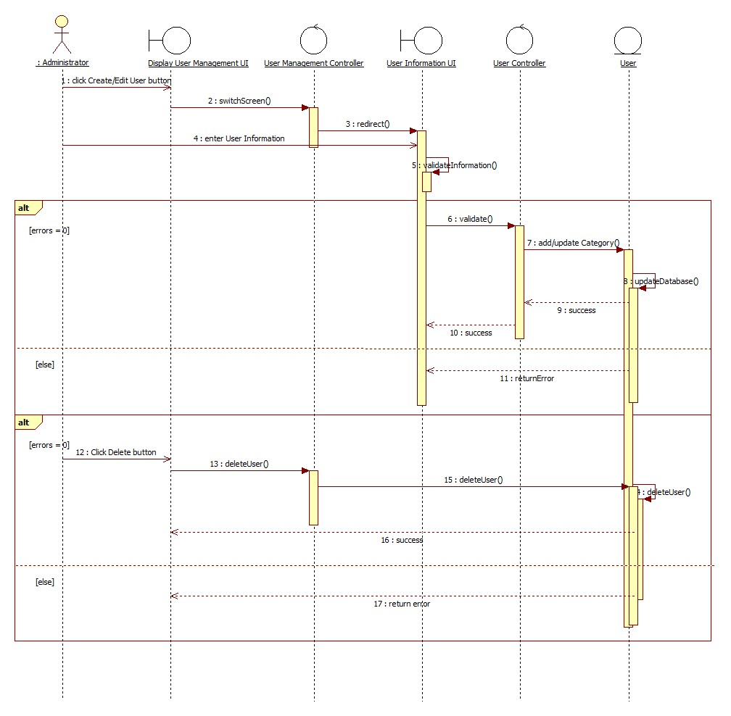
* User Register
When a user enters their phone number and password, the system will send back an OTP for the user’s phone number to check for the validity of the user's phone number. If the phone number is invalid, the system will send an error message and prompt the user to enter the information again. If the phone number has already been registered, the system will notify the user that the number has been used and will request that they enter it again.
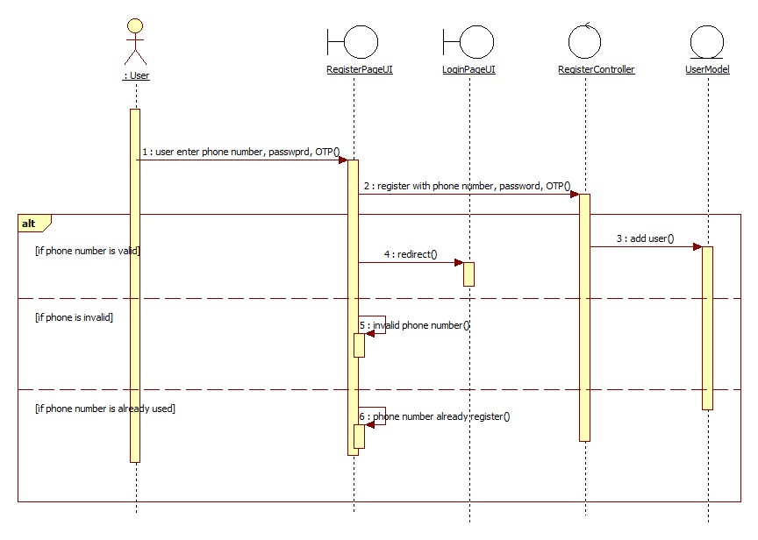
* User Log-in into the system
When a user enters their phone number and password, the system verifies that the information is valid and that the input values are correct. If the phone number and password are incorrect, the system will generate a credential error warning and ask the user to enter the information again.
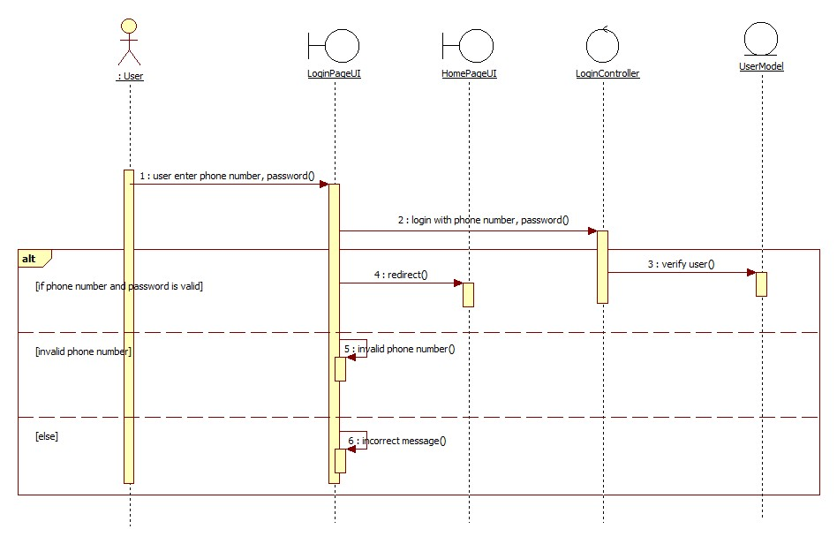
* Make Payment
If customers have more than 1000 coins, they can choose to pay with coins to proceed the purchase then the system will return a successful message. The same thing goes with pay with cash.
When the user chooses to pay with an online app, a pop-up modal will appear with a QR code. If the customer scans it successfully, the system will proceed to purchase and return the customer a successful message.
When the customer chooses to pay with their credit card, if their card's information is valid, the system will proceed to purchase and return a successful message.
When the customer chooses to pay with their visa card, if their card's information is valid and still unexpired, the system will proceed to purchase and return a successful message.
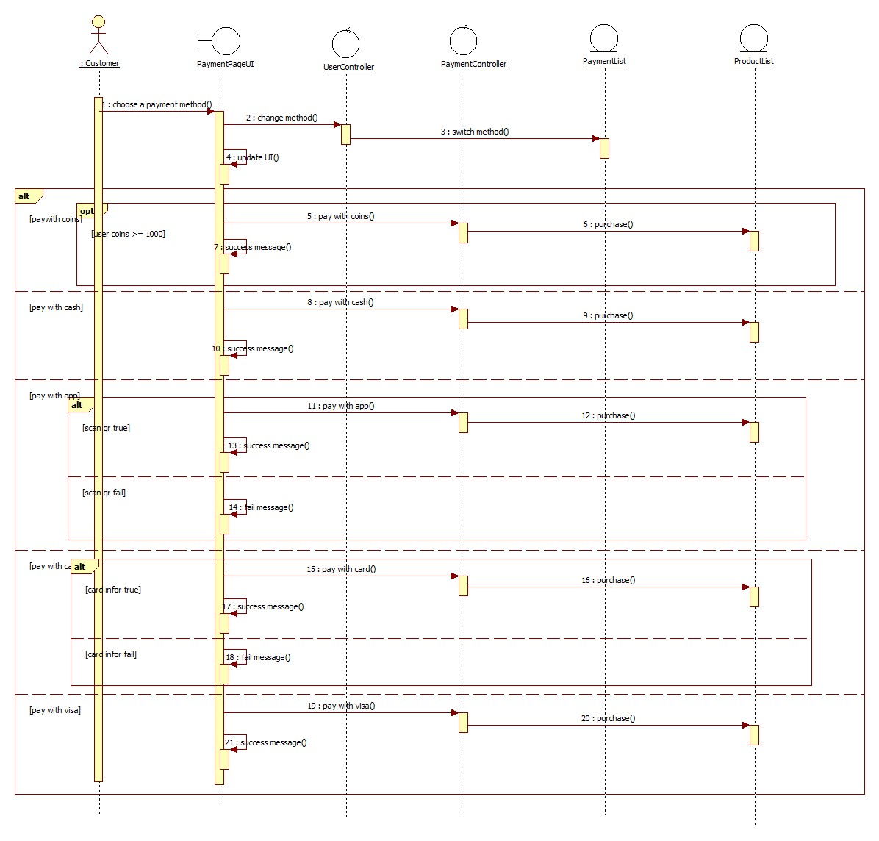

* Create Collections
When sellers click the "Create New Collection" button, the system will prompt them to input the necessary information for the collection. If the provided information is valid, the system will proceed to create the collection, update the database accordingly, and refresh the collection page view to display the new collection. If the information is invalid or incomplete, the system will return an error message, highlighting the specific issues that need to be addressed before the collection can be successfully created.
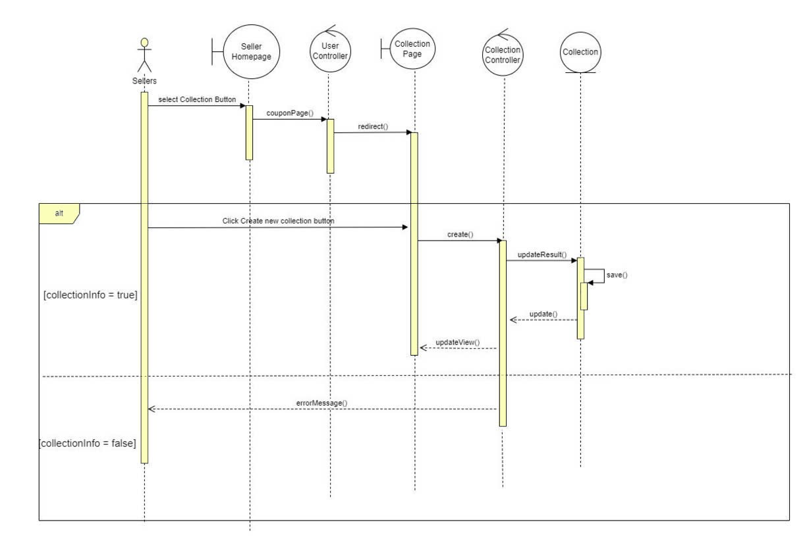
* Edit Collections
When sellers click the "Edit" button, the system will display a pop-up modal that allows them to make changes to the collection information. Once the seller has made the necessary edits and confirms the changes, the system will update the information in the database accordingly. After the update is complete, the Collection Page will be refreshed to reflect the edited collections, ensuring that the most current information is displayed to users.
* Manage Cart
When the customer click on the cart icon on the homepage, the user will be redirected to the manage cart page. The customer select products, change the product quantity and the system will count how many the user has select and get the changed the products quantity. When the customer clicks Delete button, the system will delete all the products that the customer has select and update the UI list, then updated the view of manage cart page
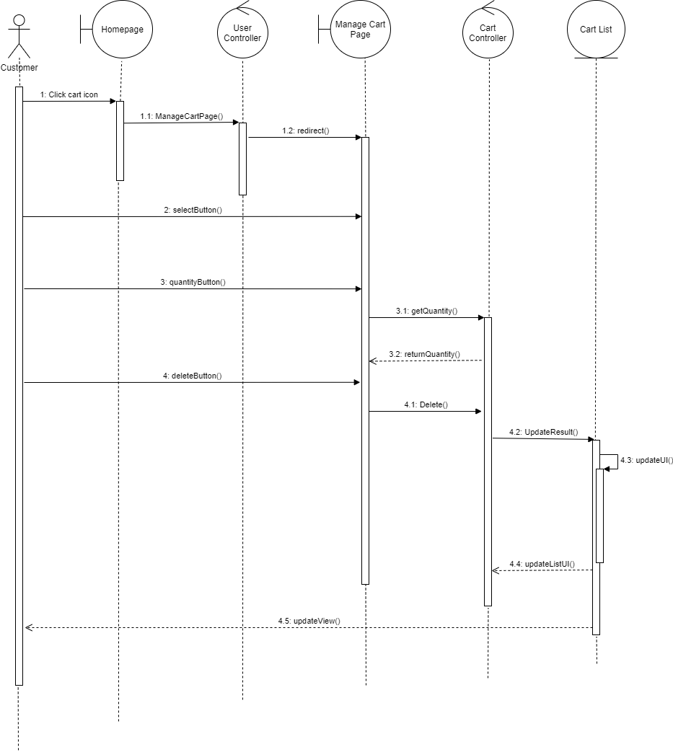
* Manage Order
When the user clicks My Order button, the system will get the order list from the database and display it right when the page redirect to the order page.
When the customer select any orders code, the system will get the orders detail by orders code and show it to the customer.
When the customer clicks View Tracking button, the system will get the data of the order and display the tracking view for the customer.
When the customer clicks the Cancel button, the system will cancel the order and update it to the database and also return an confirm message.
When the customer clicks Write Review button, the system will make a form for the user to type in. After the user commit the review, the system will receive the data then update it to the database and also send back an confirm message.
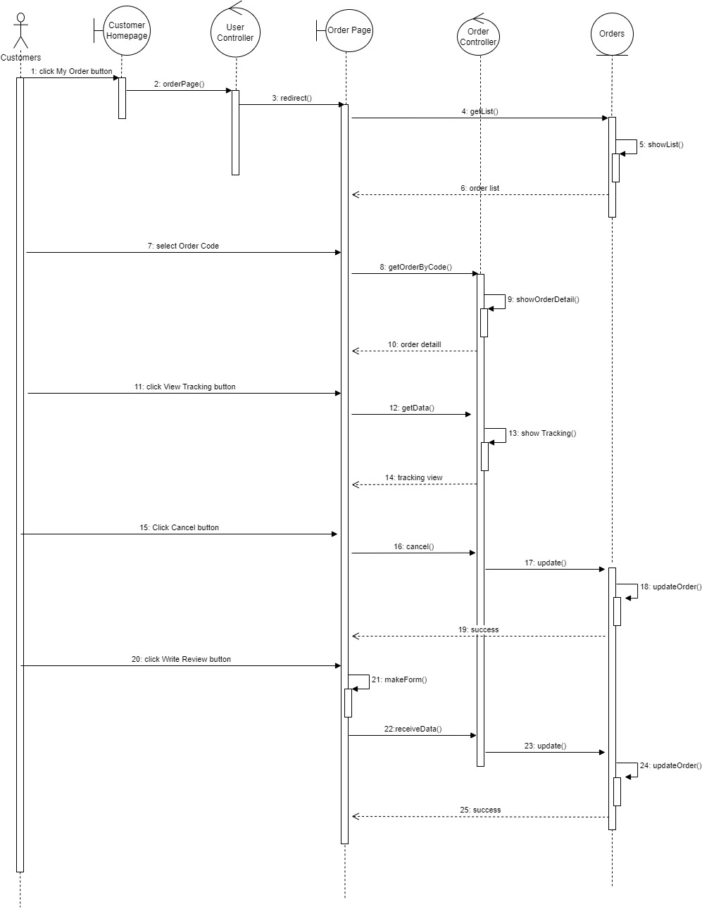
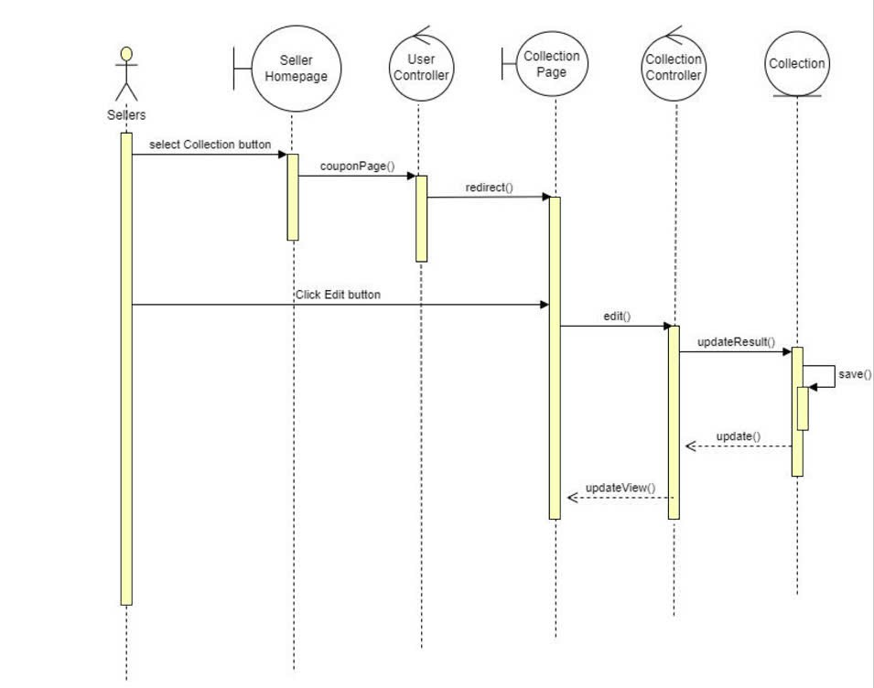
* Delete Collections
When sellers click the "Delete" button for a collection, the system will initiate the deletion process for the selected collection. Upon confirmation from the seller, the chosen collection will be removed from the database. After the deletion is successful, the system will update the Collection Page to reflect the changes, ensuring that the deleted collections are no longer displayed.
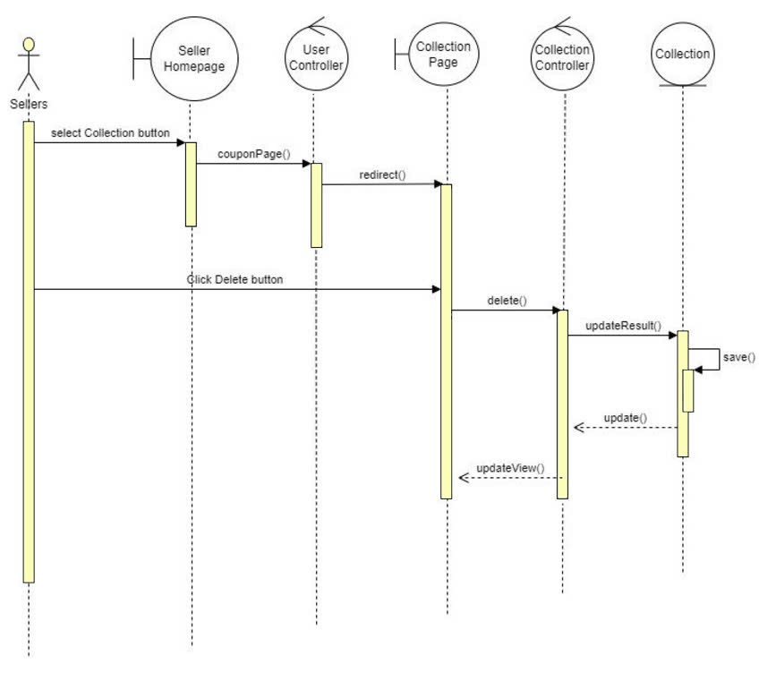
* View Collections
When sellers perform a search by name, the system will capture the text input from the seller. It will then search the database for all collections that contain a similar name (using string matching). The system will return the search results and update the page view to display the relevant collections.
If the seller chooses a specific status, the system will request a list of collections that match that status from the database. Upon receiving the list, the system will update the page view to show the collections that correspond to the selected status.
Additionally, if the seller selects a specific collection name (e.g., "Line"), the system will send the collection ID to the database to retrieve the detailed information about that collection. Once the details are received, the system will update the page view to display the returned collection details.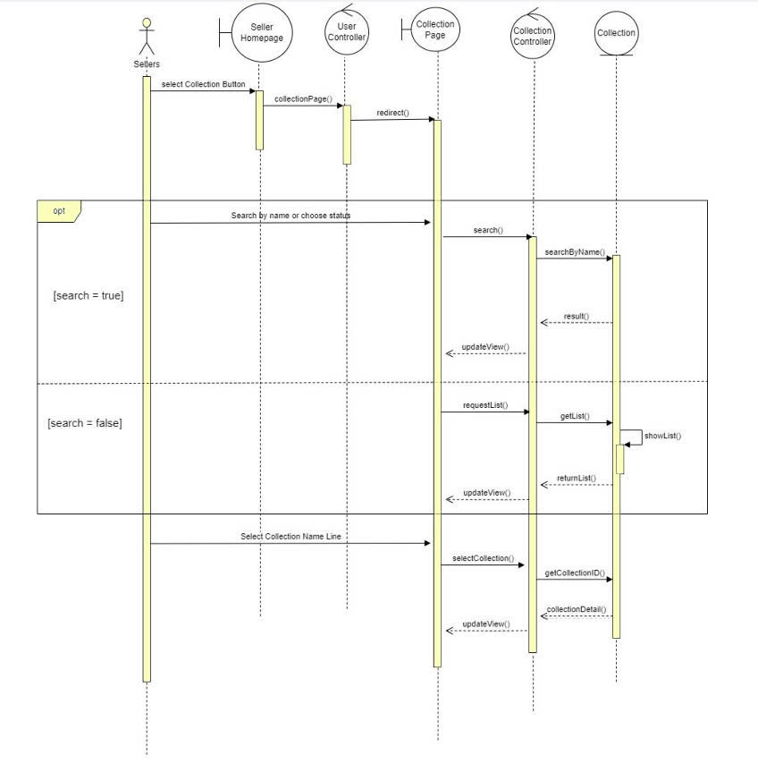
* Create Coupons
When sellers click the "Create New Coupon" button, the system prompts them to input the necessary information for the coupon, such as the coupon code, discount amount, expiration date, and terms and conditions. If the provided information is valid, the system creates the coupon, updates the database, and refreshes the coupon page view to display the new coupon. However, if the information is invalid, the system returns an error message detailing the specific issues, allowing the seller to correct the input before attempting to create the coupon again.
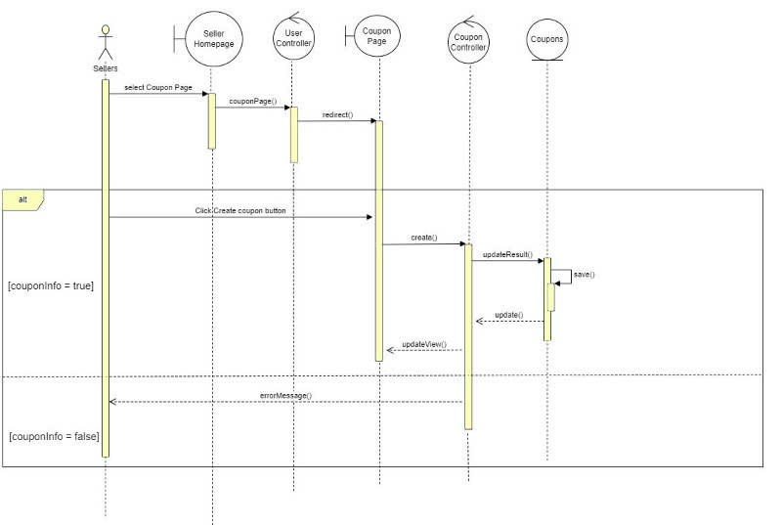
* Edit Coupon
When sellers click the "Edit" button for a coupon, the system will display a pop-up modal that allows them to modify the coupon details, such as the coupon code, discount amount, expiration date, and any terms and conditions. Once the seller has made the necessary changes and confirms the edit, the system will update the coupon information in the database. Following this update, the Coupon Page will refresh to reflect the edited coupon, ensuring that the seller sees the most current information.
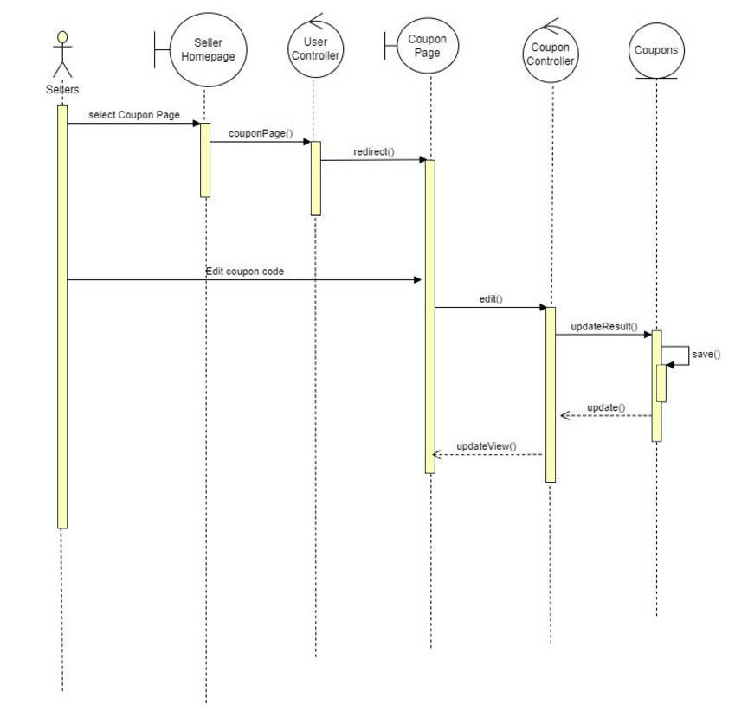

* View Coupon
When sellers search for coupons by name, the system will capture the text input from the seller and perform a string search to find all coupons with similar names. The search results will then be returned and the page view will be updated to display the matching coupons. If the seller chooses a specific status, the system will request a list of coupons corresponding to that status from the database, which will then be returned and used to update the page view with the relevant coupons. Additionally, if the seller selects a coupon code, the system will send the coupon ID to the database to retrieve detailed information about that coupon, subsequently updating the page view with the returned details.
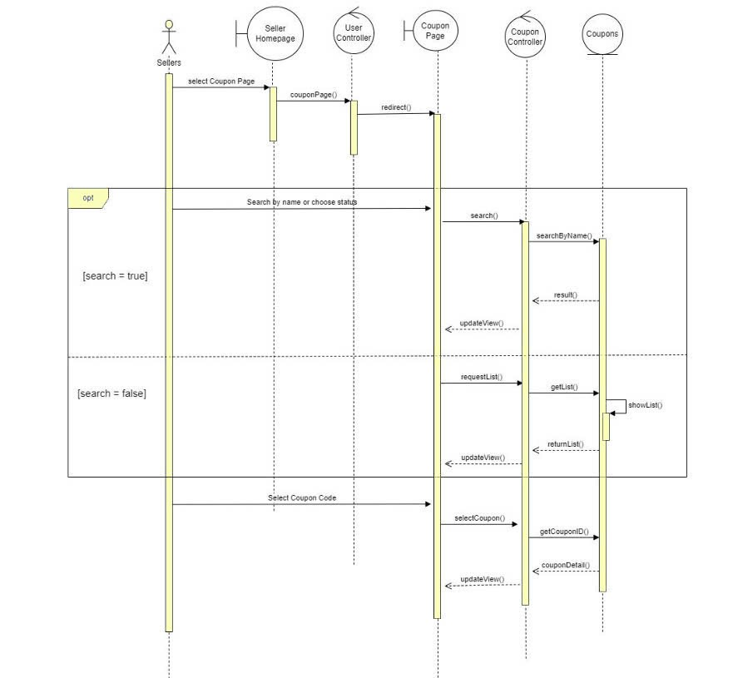

* Create existing product
This use case outlines in detail how sellers are involved in the interaction with this system in order to search for coupons and view them. Sellers can type coupon names to search for and the system looks through strings to find matching coupons to display. On the other hand, sellers can filter coupons based on the status by inputting the preferred status then the system brings the list from the database. If a seller chooses a coupon code, the system pulls specific coupon details from the database and replaces the page view with the latest information.
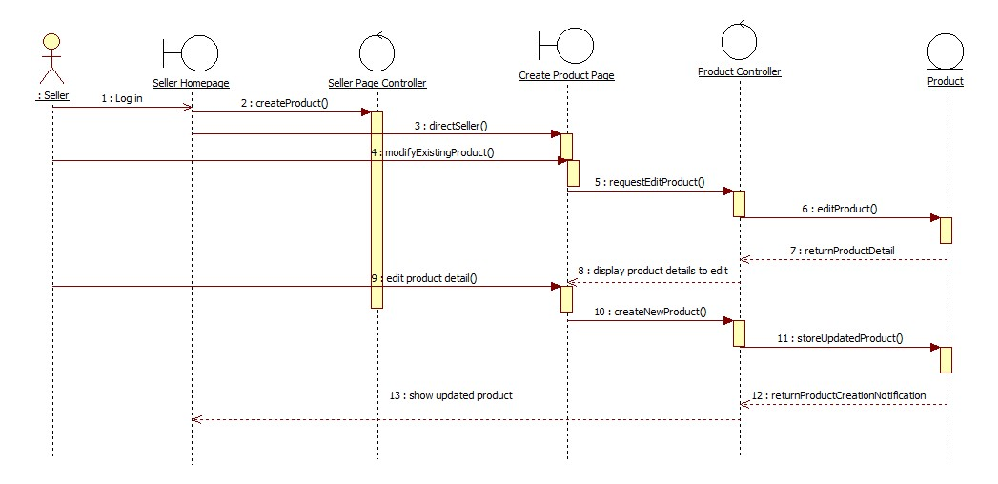
* Search product by name/category
In this use case, buyers can look for products via either categories or names. On the Buyer Homepage, the buyer selects a category when searching by it. This request is processed in the UserControl and SearchController, sending matching products to the ProductDocument. When searching by name the buyer enters a product name in the search field and searches alternatively. It's looking for a string match from ProductDocument then it performs a string search for matching products. In both instances the search result comes out to the ProductList interface for the buyer to see.
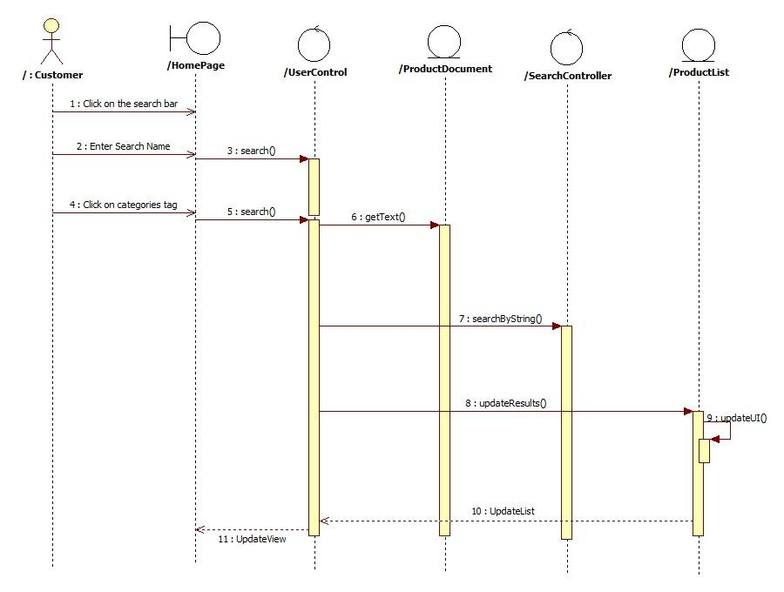

Deployment View
N/A

Implementation View
N/A

Overview
N/A

Layers
N/A

Size and Performance
The software's primary dimensioning factors that influence architectural and performance constraints:At any given time, the system should be able to support up to 1000 - 4000 concurrent users against the primary database, and up to 3000 concurrent users against the local servers.All functions of the system must be completed with minimal time delays. The system must also accurately save all product and transaction information.

Quality
The system architecture supports the quality requirements:
- The system is capable of ensuring that all information transitions are saved in order to maintain the highest level of system integrity.
- Databases will be backed up on a daily basis due to security concerns.
- The system's website can be viewed on a variety of devices and web browsers with varying screen sizes (i.e. responsive design).
- Google Chrome, Mozilla Firefox, Opera, Safari, Microsoft Edge, and Internet Explorer must all be able to access all website system functions.
- The system app can be installed in some Operating System like Android and IOS.

